**SMART WALKING STICK**

**Project Report**

***Submitted in partial fulfillment of the***

***requirement for the course of***

**INTRODUCTION TO INNOVATIVE PROJECTS [PHY1901]**

***By***

***Yeshwanth.P (Reg.No 19BCE1862)***

***Vikram.G (Reg.No 19BAI1144)***

***Barath Hari Hara Moorthy.R(Reg.No 19BAI1160)***

***Vikrant Thoidinjam(Reg.No 19BPS1006)***

***Saripella Teja Naga SuryaVarma (Reg.No 19BCE1069)***

***Surya Ganesh(Reg.No 19BCE1736)***

***To***

**Dr. Ajitha.B**



**SCOPE**

**VIT Chennai**

**CHENNAI – 600127, Tamil Nadu, India**

**List of 10 issues from all team members**

**BARATH HARI HARA MOORTHY**

Illiteracy

Global warming

Pollution

Racism

Dowry

Unemployment

Debt

Poverty

Women molestation

Child labour

Marketing problems in agriculture

Casteism

Physically challenged people's suffering

Child abuse

Corruption

**Vikrant Thoidinjam:**

Global Warming

Overpopulation

lack of waste management

immigration issues

deforestation

cultural unification

Lack of educational institutes.

Lack of health institutes.

Sanitary and food related issues

Religion related issues

Civil right issues

Wage gap

Uneven money distribution

**Vikram G:**

Corruption

Illiteracy

Woman Safety

Basic Sanitation

Healthcare system

Poverty

Unemployment

Loss of Agriculture

Pending Justice

Loss of Humanity

**P.YESHWANTH:**

Harassment and injustices against women

helping others

Helping the people who are in need of help like physically challenged

Fake feminism

Doing activities that affect the environment

caste biased perception of individuals

gender biased perception

caste biased perception

corruption

people in power misusing their authority

Not respecting Love

unequal distribution of resources

Poverty

***Saripella Teja Naga SuryaVarma :***

**OBESITY**

**SMOKING**

**YOUTH ALCOHOL USAGE**

**TRANSPOTATION**

**POVERTY**

**BASIC NEEDS**

HOMELESSNESS

HOMELESS POPULATION

TEEN VIOLENCE AND ABUSE

TEEN DEPRESSION AND SUCIDE

**BRAINSTORMING**

***P.YESHWANTH***

**Deprivation of Humanity in People**

**Importance of Humanity:**

Humanity is nothing but the quality of being humane to our fellow human beings. In the fast paced world currently, most people tend to have no time to even to save to help a person who met with a severe accident. This started when people started pricing life. For example the life of a wealthy millionaire is valued more than that of a man under the poverty line. This is where the loss of humanity started .

**One can lose one’s humanity in various contexts.**

(a) Anyone who harbors hate or contempt for a fellow being on the basis of skin-color or ethnic background has lost his/her humanity, if he/she ever had it.

(b) Anyone who looks down upon and/or hates fellow human beings who belong to another religion or no religion at all has lost his/her humanity.

(c) A person who is bitterly hateful of all the *people* of another nation with which one’s own nation is at war has lost his/her humanity.

(d) A person who needlessly engages in cruelty to animals has lost his/her humanity.

**One can lose one’s humanity by choice:**

(a) By joining groups whose tenets include hatred for other groups.

(b) By following those parts of any religion that teach one to regard unbelievers in that religion or denomination as evil.*It is important to remember that all religions teach us to love and help fellow humans*. But there are elements in all religions that devalue people who follow other sects or faiths. These sprang from historical reasons, and could be discarded without abandoning the religion. It is only these aspects of religions that dehumanize us.

**How to prevent Loss of Humanity in People:**

The first foremost responsibility goes to people ourselves. When a child is brought up he should be taught that all people are equal despite their caste creed religion or complexion.

Schools also play a big role in this as students from various backgrounds are going meet and mingle with others. If a child is brought up in this way he would never show partiality among people and eventually he will be a good human being with a tendency to help other people without a thought.

The Government should also take steps to spread awareness on this issue in deep rural parts of our country where the caste system and creed are sensitive and critical issues to face with.

We should take a initiative so that at least the next generation gives importance to humanity more than caste creed religion or complexion.

***Vikram G***

Effects of Corruption:

**Corruption in India** is an issue which affects the economy of central, state and local government agencies in many ways. Not only has it held the economy back from reaching new heights, but rampant corruption has stunted the country's development.[[1]](https://en.wikipedia.org/wiki/Corruption_in_India" \l "cite_note-tfe2010-1) A study conducted by [Transparency International](https://en.wikipedia.org/wiki/Transparency_International) in 2005 recorded that more than 62% of Indians had at some point or another paid a bribe to a public official to get a job done.

How to control this increasing corruption in our country?

There are several bodies that are working for a corruption free system. Here are suggested some of the tools to reduce corruption:

**1.The first tool is ‘Education’**.

With the help of education we can reduce corruption. According to a report by Transparency International, the least corrupt state is Kerala, the reason being that Kerala’s literacy rate is highest in India.

**2. We need to change the government processes**.

If the members of the governing body are government officials, there will certainly be less reports of the criminal cases. The reverse may be possible only when there are no more criminal politicians in our government. The provision is that, if there is any case filed against a person then he would not be eligible for election.

**3. We can reduce corruption by increasing direct contact between government and the governed**.

E-governance could help a lot towards this direction. In a conference on, “Effects of Good Governance and Human Rights“ organised by National Human Right Commission,

A. P. J. Abdul Kalam gave an example of the Delhi metro rail system and online railway reservation as good governance and said that all the lower courts should follow the example of the Supreme Court and High Court and make judgements available online.

**4. Lack of effective corruption treatment** is another reason.

That means, instruments which are in use, are not running properly. Despite the Prevention of Corruption Act 1988, corruption is still flourishing. Why? Because of weak actions and proceedings towards corrupt people. People don’t have any fear of this act and the court. The act may thus be revised for its better implementation.

**5. Lack of transparency and professional accountability is yet another big reason.**

 We should be honest to ourselves. Until and unless we will not be honest, we can’t control corruption. If each of us is honest towards our profession, then corruption will automatically decrease.

***Barath Hari Hara Moorthy.R***

MARKETING IN AGRICULTURE

Agriculture marketing refers to all the process which relate to taking the produce from the farmers to the consumers.

The produce gathered is segregated and provided to various middlemen from the farmers.

Even though India is an agricultural country, still the marketing has been defective. The farmers that work hard are not getting paid properly for their produce while the middlemen are getting rich.

One of the main problems in marketing is the play of middlemen, though the government are helping to sell the farmers their produce they are not getting paid the right amount.

I propose that we have a database separately for the farmers marketing side. This database will contain all the details of the farmers registered like his land size and the crop grown in that season, and a standard price rate for each crop according to the economy at that time. The government will now purchase the crop from the farmers according to the database for the proper price eliminating the middlemen.

Now to privatize the market, retail sellers have to buy the crop from the government rather than the farmer that way the price is standard and the farmer gets his price for his hard work.

***Vikrant Thoidinjam***

Economic gap – people in poverty

Nowadays people are divided into rich and poor depending on their parents, the place they were born or due to other issues.

The people in the later state has been suffering due to the huge gap of livelihood even after working the same amount or more than the former. They take to illegal and dangerous works to make their ends.

So they get harmed in this process but other people are not affected by this which is wrong as loss of humanity is a big loss to the world we live in.

***Surya Ganesh***

**Loss of power in rural Areas**

The rapid development of human race took place only after the discovery of electricity. From lighting homes, to running factories, powering computers the use of electric power is immense.

But unfortunately sharing of power is uneven. People in rural areas do not have access to continuous power supply. When we people in city enjoy uninterrupted power there by having access to knowledge as well as entertainment, people in rural areas are not able access basic amenities like lights, fans during summer, running motors to pump water to their fields.

This has become even more grave during this lockdown due to corona virus. Students in rural areas are losing out on education due to lack of power whereas city bred students are able to continue their education uninterrupted through online.

Power disruption has widened the rural urban divide. The lack of political will also hampers electrification of rural areas

One fifth of rural households still live in darkness. Disruptions discourage rural households on adopting electricity.

Meanwhile, poor reliability forces them to also use traditional fuels, like kerosene and fuelwood, for lighting and cooking purposes. In effect, these households end up paying for two power sources. Unsurprisingly, this affects rural households’ decision making when it comes to electricity adoption.

Without electricity, that also means no fans or air conditioning, and no classes or study time during evenings as there is no adequate source of light. It also affects school attendance, as many children are burdened with the responsibility of collecting firewood or clean drinking water for their families.

***Saripella Teja Naga SuryaVarma***

Homelessness is a major issue in India. The Universal Declaration of Human Rights defines 'homeless' as those who do not live in a regular residence due to lack of adequate housing, safety, and availability.[1] The United Nations Economic and Social Council Statement has a broader definition for homelessness; it defines homelessness as follows: ‘When we are talking about housing, we are not just talking about four walls and a roof. The right to adequate housing is about security of tenure, affordability, access to services and cultural adequacy. It is about protection from forced eviction and displacement, fighting homelessness, poverty and exclusion.[2] India defines 'homeless' as those who do not live in Census houses, but rather stay on pavements, roadsides, railway platforms, staircases, temples, streets, in pipes, or other open spaces.[1] There are 1.77 million homeless people in India, or 0.15% of the country's total population, according to the 2011 census consisting of single men, women, mothers, the elderly, and the disabled.[1][3] However, it is argued that the numbers are far greater than accounted by the point in time method. For example, while the Census of 2011 counted 46,724 homeless individuals in Delhi, the Indo-Global Social Service Society counted them to be 88,410, and another organization called the Delhi Development Authority counted them to be 150,000.[2] Furthermore, there is a high proportion of mentally ill and street children in the homeless population.[4] There are 18 million street children in India, the largest number of any country in the world, with 11 million being urban.[5][6] Finally, more than three million men and women are homeless in India's capital city of New Delhi; the same population in Canada would make up approximately 30 electoral districts.[7] A family of four members has an average of five homeless generations in India.[1]

There is a shortage of 18.78 million houses in the country. Total number of houses has increased from 52.06 million to 78.48 million (as per 2011 census). However, the country still ranks as the 124th wealthiest country in the world as of 2003.[8] More than 90 million people in India make less than US$1 per day, thus setting them below the global poverty threshold.[8] The ability of the Government of India to tackle urban homelessness and poverty may be affected in the future by both external and internal factors.[8] The number of people living in slums in India has more than doubled in the past two decades and now exceeds the entire population of Britain, the Indian Government has announced.[9] About 78 million people in India live in slums and tenements.[10] 17% of the world's slum dwellers reside in India.[8] Subsequent to the release of Slumdog Millionaire in 2008, Mumbai was a slum tourist destination for slumming where homeless people and slum dwellers alike could be openly viewed by tourists.

**INDIVIDUAL CONTRIBUTIONS:**

Yeshwanth:

I will contribute to the coding part of the obstacle detection ultrasonic sensor which will detect the distance between objects in real time

Vikram :

My contribution will be attaching the ultrasonic sensor to the stick and verify its accuracy by plotting a graph and by observing the linear curve and from this I can find out the error in distance measurement

Barath:

My contribution will be make the audino board work and fixing it in the box inside the walking and solve all the issues related to audino board and its working

Surya:

My contribution will be to insert the buzzer alarm which will alert the user by giving the sound. I will do all the works related to this buzzer fixing and working and also its technical functionality

Vikranth:

My contribution to this project will be assembling the hardware for the walking stick like making stick from PVC pipe,etc.

S.T.N.S. Varma:

I will contribute to the project by taking care of the wiring and the interconnections of the components and overall connections

**TABLE OF CONTENTS**

|  |  |
| --- | --- |
| **S.NO** | **TITLE** |
| **1** | **ABSTRACT** |
| **2** | **INTRODUCTION** |
| **3** | **MINDMAP** |
| **4** | **METHODOLOGY** |
| **5** | **COMPLETION STATUS** |
| **6** | **EXPECTED OUTCOME** |
| **7** | **YOUR NOVELTY** |
| **8** | **CONCLUSION** |
| **9** | **REFERENCE** |

1. **ABSTRACT:**

This project report presents the smart walking stick based on ultrasonic sensors and Arduino for visually impaired people or aged people who suffer due to half blindness. There are approximately 37 million people across the globe who are blind according to the World Health Organization. People with these kind of disabilities are often dependent on external assistance provided by humans, trained dogs, or special electronic devices as support systems for decision making. Thus, we were motivated to develop a smart walking stick to overcome these difficulties. We accomplished this goal by adding ultrasonic sensors at specific positions to the stick that provided information about the environment to the user by activating the buzzer sound. We proposed this design with microcontroller that processes signal and alerts the visually impaired person over any obstacle, water or dark areas through buzzer sounds. The system consists of sensors for receiving, processing and sending signals to the alarm system based on obstacle and moisture detection which finally alerts the user to proceed accordingly. Though the system is designed, it is yet to be programmed using C language and tested for accuracy and checked by the visually impaired person. This device can detect obstacles within the range of 2m from the user. The object is detected with the help of a camera and also it measures the distance between objects by using ultrasonic sensor and indicates the user. If any obstacle comes in front of blind person, he/she can know about the obstacle by hearing the sound generated by the head phone. The system is very useful for people who are visually impaired and are often in need of the help from others.

1. **INTRODUCTION:**

This project presents the “SMART WALKING STICK”. Many visually impaired and blind people are struggling to walk through the right path in their day to day lives. Thus arrived the thought of bringing something new to them which will be easy and useful thing for them to make their life more easable. So we thought of making SMART WALKING STICK. The advantage of our project is that it can detect any obstacle with the help of ultrasonic sensors and also it can provide correct location of obstacle by using the GPS system. Thus it will help blind people when they are walking outside from their home. The only aim is to bring this project is to remove the curse of blindness and make visually impaired people self dependent to do their daily chores. Visually impaired people have difficulty to interact and feel their environment. They are totally deprived from the surroundings. Navigation is a challenge for visually impaired persons, because it can become tricky to distinguish obstacles appearing in front of them, and they are not able to move from one place to another. This project report clearly establishes our though of helping the aged and blind people with the aim of detecting and combing the information in the view of helping visually challenged people in terms of obstacle detection, location information, panic situations. This project involves assembling the arduino smart cane, attaching the components to the smart cane and programming the code for the proper functioning of the system.

1. **MINDMAP:**

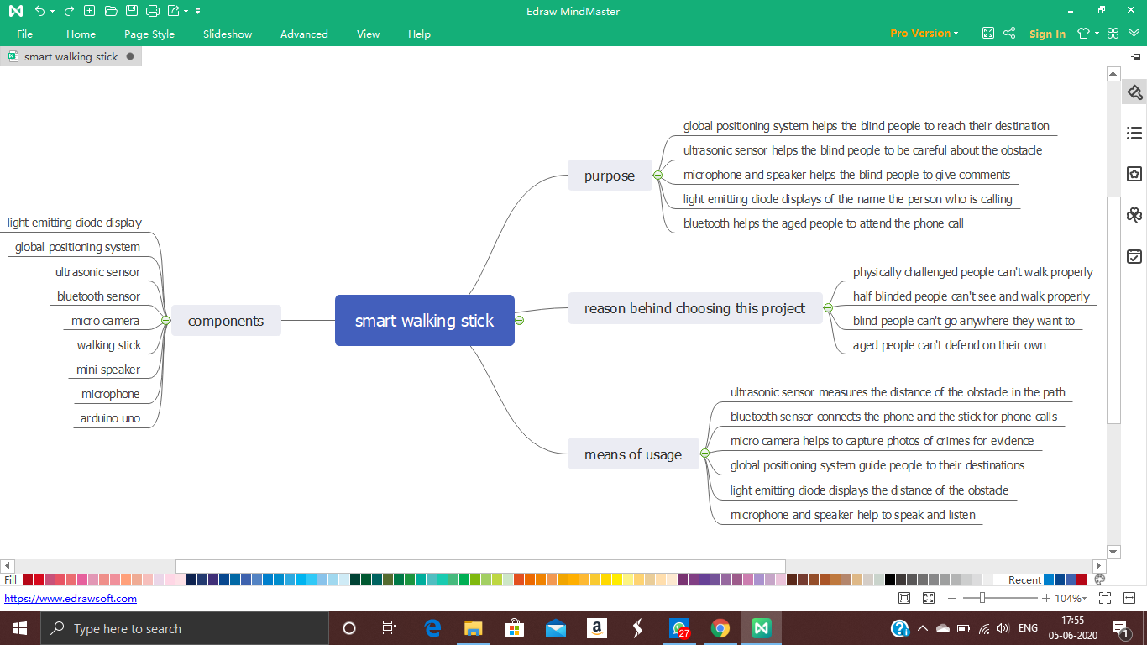

1. **METHODOLOGY:**

The visually challenged people face a lot of social problems on a daily basis such as navigating around the places, obstacle detection, location information, panic situations and difficulty in handling emergency situations. Hence our aim was to remove the curse of blindness and to make visually impaired people self dependent to their daily chores. It is a walking stick normally used by blinds. It will be extremely helpful as it is equipped with many good latest and innovative features.The plans about the features we planned to install in the walking stick are as follows:

**4.1. INNOVATION:**

**4.1.1. OBSTACLE DETECTION:**

The result will be found by using ultrasonic sensors to detect obstacles accurately. The measured distance to the obstacles will also be approximately correct. For comparing the obtained results to real distance, a graph is plotted from which we get a linear curve. This indicates the error in distance measurement is small.

**4.1.2. LOCATION INFORMATION:**  
The application will be designed using android studio and google map API which provides user location so that the parents can locate the user. It also contains mini microphone and speaker so that the user can send messages to people when in danger along with their location as well.

* + 1. **PANIC SITUATIONS:**

In some situations visually challenged people face many difficulties in an unfamiliar environment or have some health issues and wish to contact their parents or friends immediately. Usually VCP’s have to depend upon others for help but the emergency application is very useful in these situations. In this system, android based emergency applications are used that is downloaded from the open source google play store. An emergency SMS and call can be forwarded to emergency contacts that are saved to the app by shaking the user self-phone or pressing the power button four times in 5secs.

* + 1. **CAMERA:**

This walking stick is basically used by blind people. This will help the person to find out and store what is happening and bring it into picture to reveal to others, which acts as an evidence. It also captures the location image with a detailed address when shaking the walking stick automatically. After that, it shows options on social media to share a picture with friends or relatives so that the user’s friends or relatives can get a better idea by looking at the image in order to find the exact location of the user in an emergency. This feature can be applicable to partially sighted people.

**4.2 MISCELLANEOUS:**

This stick is equipped with arduino uno and ultrasonic sensors too. It has light emitting diode display which will be very much useful to blind people in a lot of difficult situations.

**4.2.1. ASSEMBLING THE ARDUINO SMART CANE:**

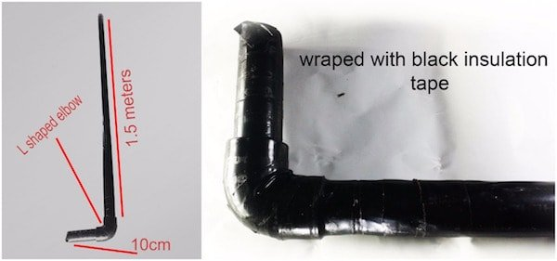

We used a PVC pipe to make the walking stick.We used a 3/4-inch diameter PVC pipe and an 'L' shaped elbow to make the walking stick. The above images shows our output of making the walking stick and follow these instructions:

**4.2.2. ATTACHING THE COMPONENTS TO THE SMART CANE**

This is the hardest step in this project. It took us hours to design and fix the parts onto the walking stick. We can use a box to put all our electronics together. We used a foam board to make a box ourselves.

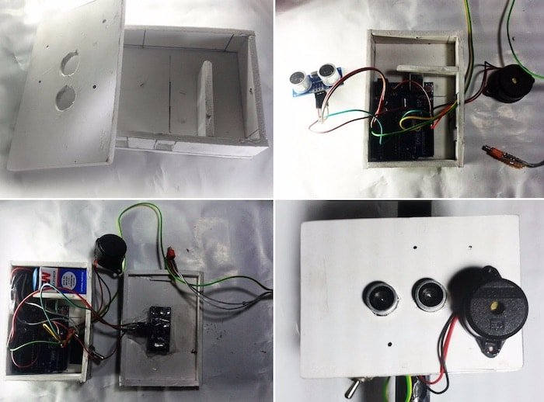

We fixed the arduino in the box using screws.We made two holes for fixing the ultrasonic sensor on the lid of the box as shown in the above image. We attached the buzzer outside of the box for better sound. We attached the toggle switch at the side of the box and made a small hole for connecting the vibration motor to the Arduino. We fixed the battery inside of the box and connected the power jack to the Arduino. After attaching the box to the walking stick, we took out the vibrator motor and fixed it below the elbow.

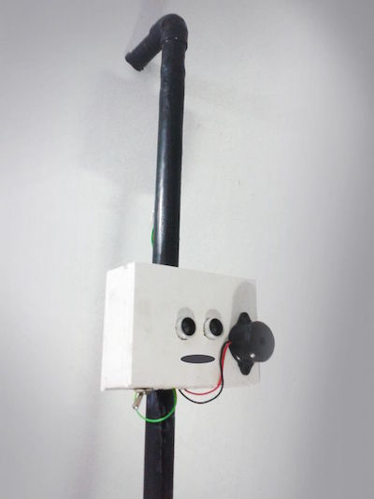

In conclusion, we had planned to code GPS , camera and LED screen that include all these features in our project. But due to arise of the unexpected global pandemic situation, we were not able to complete the exact final model as expected on time. Therefore the upcoming sections will explain how far we have got the work done.

**5. HOW FAR HAVE WE COMPLETED:**

Due to the current pandemic situation we are not able to buy and assemble the parts of the smart walking stick, but for now we have finished the coding part of the aurdino.

**6. EXPECTED OUTCOME:**

A walking stick is commonly used by the visually impaired or as a support to the legs. The walking stick we hope to produce will factor in different struggles suffered by these people to provide maximum comfort. Other than the basic uses of an usual walking stick, we have included a camera, a GPS, a Bluetooth, a speaker, motion sensor and a distress button.

**6.1. The microcamera: T**the camera was placed there to record the surrounding of the user and would help provide a clear picture in case any troubling situation were to arise. It would also help to provide a peace of mind to the user’s cared ones if they were able to check in with them.

**6.2. GPS:** The main function of the GPS is to not only to sooth the user’s closed ones by being aware of the users location but also to provide directions to their destination and prevent them from getting lost. It would provide the basic information provided by the Google maps like the shortest routes possible and least traffic areas etc.

**6.3. Bluetooth :** This helps in sharing the information in the stick to other devices so the information can be kept safe and can be reviewed any time for future reference.

**6.4 Speaker:** Speaker is provided to aid the visually impaired to receive information from the walking stick like the directions to reach their destination and helps them to easily understand. It can also be used to play music.

**6.5 Motion sensor:** This provides the visually impaired users a great help to navigate their way in their surroundings. The motion sensor would warn the user any object in their vicinity so they could become aware and navigate themselves accordingly.

**6.6 A distress button :** It is added so if the user were to find themselves in trouble and in need of assistance then pressing this button would alert their caretakers of their need for help and would also provide the exact location of the user.

**7. YOUR NOVELTY :**

While the walking stick in itself is not new, the modification provide to it is a thought of our own. This, which we are trying to create, does not only provide a solution to one difficulty faced by the users by takes into consideration the various aspects they struggle with in day-to-day life and hopes to ease some of the burdens they bear. It provides a better and a much easier way to be aware of their surroundings and also provides safety in various cases. The things we have taken as components are nothing special but put together it provides the maximum comfort that we can provide using today’s technology to help the user.

**8. CONCLUSION :**

The smart walking stick is constructed and will help the blind people to navigate from one place to another without others help. This could be considered a crude way of giving the blind a sense of vision. This walking stick reduces the dependency of aged or blind people on other family members, friends and guide dogs while moving around. The combination of various working units makes a real-time system that monitors the position of the user and provides dual feedback making navigation more safe and secure. The smart walking stick detects objects or obstacles in front of users and feeds warning back, in the form of voice messages rather than vibration. The advantage of the system lies in the fact that it can prove to be a low cost solution to millions of blind person worldwide.

**9. REFERENCES:**

[www.sciencedirect.com](http://www.sciencedirect.com/)

[www.webcapable.com](http://www.webcapable.com/)

[www.seniority.in](http://www.seniority.in/)

[www.wikepedia.com](http://www.wikepedia.com/)

https://rekordeast.co.za/356110/video-visually-impaired-blind-and-disabled-tired-of-handouts/

https://www.wsj.com/articles/how-to-make-artificial-intelligence-less-biased-11604415654

https://www.letsenvision.com/blog/challenges-blind-people-face-when-living-life